[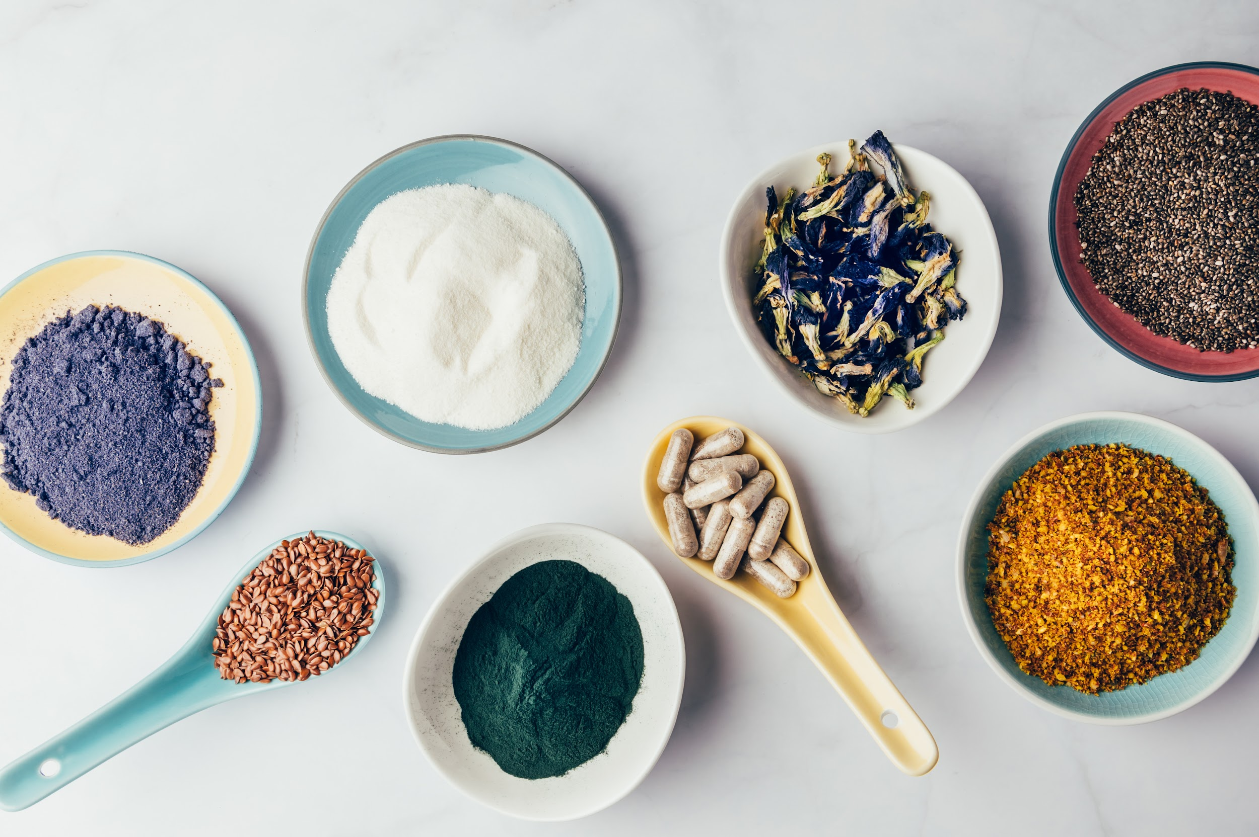](https://ca.fullscript.com/)

According to the Centers for Disease Control and Prevention (CDC), about 35% of adults sleep less than the recommended seven hours per night. Sleep is important for good health, and lack of sleep may be linked with long-term health conditions, including heart disease, depression, and diabetes.

Improving your sleep health can involve various lifestyle practices, known as sleep hygiene, and certain dietary supplements. Outlined below are some top supplement ingredients to support sleep quality.

### The following are some of the top ingredients recommended on Fullscript for sleep.

[](https://ca.fullscript.com/)

### **GABA**

GABA (gamma-aminobutyric acid) is a naturally occurring chemical compound produced in the brain that inhibits the excitability of neurons (brain cells). A study found that GABA supplementation improved elderly individual’s ability to fall and stay asleep. It also reduced nighttime urination (peeing) and feeling drowsy in the morning. Another study using electroencephalogram (EEG) monitors found that GABA supplementation reduced the time it takes to fall asleep by approximately five minutes, suggesting it can help people fall asleep more quickly.

### **Find** [**GABA-containing supplements**](https://ca.fullscript.com/o/catalog?ingredients_array=%7B%22name%22%3A%22GABA%22%2C%22searchAttributes%22%3A%7B%22id%22%3A%22SW5ncmVkaWVudC01NzU%3D%22%2C%22addon%22%3A%7B%22dose%22%3A0%2C%22symbol%22%3A%22gte%22%2C%22unit%22%3Anull%7D%7D%7D) **on the Fullscript catalog.**

### **Lemon balm**

The botanical herb Melissa officinalis L., commonly known as lemon balm, has long been used in European and Iranian traditional medicine. Contemporary research suggests that lemon balm may reduce stress, improve mood, and have an anxiolytic (anxiety-reducing) effect. One study in stressed individuals with sleep disturbances found that supplementing with a specific lemon balm extract over 15 days was linked with less anxiety symptoms and better sleep.

### **Find** [**lemon balm-containing supplements**](https://ca.fullscript.com/o/catalog?ingredients_array=%7B%22name%22%3A%22Lemon+Balm%22%2C%22searchAttributes%22%3A%7B%22id%22%3A%22SW5ncmVkaWVudC0xNjY4%22%2C%22addon%22%3A%7B%22dose%22%3A0%2C%22symbol%22%3A%22gte%22%2C%22unit%22%3Anull%7D%7D%7D) **on the Fullscript catalog.**

### **Magnesium**

As an essential mineral, magnesium plays a role in many of the body’s daily functions. Magnesium is involved in regulating sleep and endocrine (hormonal) systems, and supplementation in older individuals over 60 shows that the mineral may help reverse some of the brain and endocrine changes to sleep that occur as we age.

Research also suggests that magnesium may help reduce leg movements and muscle twitches that are associated with more frequent nighttime awakenings. You can get more magnesium in your diet by eating spinach, beans, nuts, avocado, and whole grains.

### **Find** [**magnesium-containing supplements**](https://ca.fullscript.com/o/catalog?ingredients_array=%7B%22name%22%3A%22Magnesium%22%2C%22searchAttributes%22%3A%7B%22id%22%3A%22SW5ncmVkaWVudC0xMjA%3D%22%2C%22addon%22%3A%7B%22dose%22%3A0%2C%22symbol%22%3A%22gte%22%2C%22unit%22%3Anull%7D%7D%7D) **on the Fullscript catalog.**

### **Melatonin**

Melatonin is a chemical naturally produced by the pineal gland of the brain. It’s released in large amounts in response to darkness to control the body’s internal clock, known as the circadian rhythm. Studies show that melatonin supplementation may improve the time it takes to fall asleep.

### **Find** [**melatonin-containing supplements**](https://ca.fullscript.com/o/catalog?ingredients_array=%7B%22name%22%3A%22Melatonin%22%2C%22searchAttributes%22%3A%7B%22id%22%3A%22SW5ncmVkaWVudC02MDQ%3D%22%2C%22addon%22%3A%7B%22dose%22%3A0%2C%22symbol%22%3A%22gte%22%2C%22unit%22%3Anull%7D%7D%7D) **on the Fullscript catalog.**

[](https://ca.fullscript.com/)