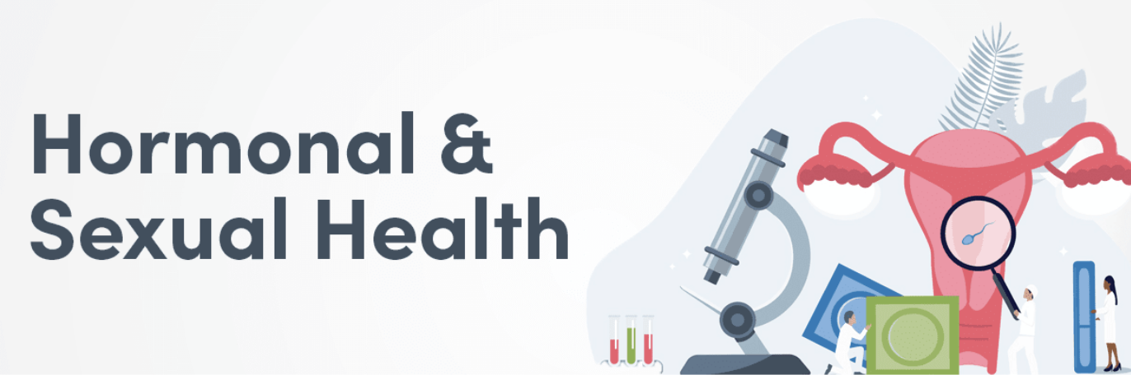

The endocrine system is responsible for producing, storing, and secreting hormones, the major chemical messengers of the body. Your hormones play a role in a variety of body processes ranging from metabolism to fertility. You can improve your hormonal health naturally by exercising regularly, consuming adequate dietary protein and fat, and managing stress. Additionally, the dietary supplement ingredients listed below may help support hormonal and sexual health.

The following are some of the top ingredients recommended on Fullscript for hormonal and sexual health.

Korean ginseng (Panax ginseng)

Panax ginseng is a medicinal herb that is commonly used in Traditional Asian medicine for its therapeutic effects. Known as an adaptogen, this herb may increase the body’s resistance to stress. In addition to its adaptogenic properties, Panax ginseng has been shown to exert effects on both male and female hormonal health. For example, research has found that Korean ginseng supplementation has been effective in addressing erectile dysfunction in men and improving symptoms of menopause in women, such as hot flashes and insomnia.

Find Korean ginseng-containing supplements on Fullscript

Maca (Lepidium meyenii)

Native to the Andes mountains of Peru, maca is a plant belonging to the Brassica (mustard) family. The root of the maca plant provides several nutrients, including amino acids, iodine, iron, and magnesium. In men with mild erectile dysfunction, maca supplementation has been shown to improve libido (sexual desire), increase sperm count, and improve the perception of sexual well-being. Similarly, maca supplementation may improve sexual function in women, as it has been shown to improve libido in menopausal women.

Find maca-containing supplements on Fullscript

Tribulus (Tribulus terrestris)

Tribulus, an annual shrub that is commonly used in Ayurvedic medicine, exerts various health effects, such as anti-inflammatory, aphrodisiac, and immunomodulatory effects. The active components of tribulus, known as steroidal saponins, have been shown to influence fertility and sexual function. Clinical research has demonstrated that tribulus supplementation may improve erectile function score in men and enhance libido in post-menopausal women.

Find tribulus-containing supplements on Fullscript

Chaste tree berry (Vitex agnus castus)

Chaste tree berry, also referred to as chasteberry or vitex, is a medicinal herb that has been used in traditional medicine systems of Egypt, Greece, and Rome for millennia. Contemporary clinical research suggests that chasteberry supplementation may reduce symptoms of premenstrual syndrome (PMS) in women, including anger, breast pain or tenderness, headache, and irritability. The health effects of chasteberry may be a result of its modulating activity on various hormones, including prolactin and progesterone.

Find chaste tree berry-containing supplements on Fullscript

