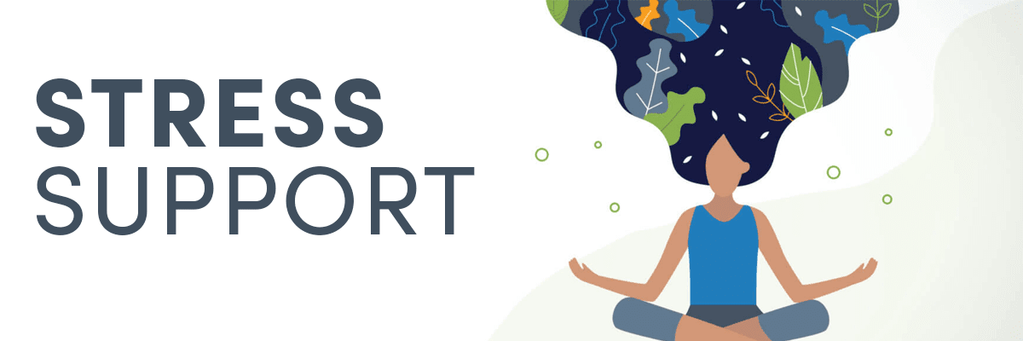
We have all undoubtedly experienced some sort of physical or emotional stress in our lives. While short-term stress is normal, long-term, chronic stress has been associated with numerous stress-related health conditions, such as anxiety, hypertension, chronic fatigue syndrome, HPA axis dysfunction, and metabolic syndrome.

Eating a healthy diet, exercising regularly, and utilizing relaxation techniques can help you manage your stress levels and keep you feeling your best. Vitamin, mineral, and herbal supplements can also help to improve your resilience to stress and support healthy adrenal gland function.

I’m offering you a discount of 5% on all of your orders through my Fullscript dispensary, so making your health a priority is easier than ever.
The following are the top ingredients recommended on Fullscript for stress.

Vitamin C
One of the highest concentrations of vitamin C in the body is found in the adrenal glands. The adrenal glands play a key role in the stress response, secreting the hormones adrenaline, aldosterone, and cortisol. The adrenal glands also secrete vitamin C as a response to stress. Research has shown that individuals supplementing with vitamin C (ascorbic acid) demonstrate lower blood pressure, faster salivary cortisol recovery, and better subjective stress responses.

Find vitamin C-containing supplements on Fullscript

GABA
Gamma-Aminobutyric acid, more commonly referred to as GABA, is a neurotransmitter produced by the body. The primary role of GABA is to reduce the excitability of neurons throughout the nervous system, inducing a calming effect. Research demonstrates that GABA supplementation reduces anxiety and improves sleep, helping individuals fall asleep faster and stay asleep longer.

Find GABA-containing supplements on Fullscript

L-theanine
L-theanine, an amino acid commonly found in green tea, is well known for promoting relaxation and improving sleep. Research has shown that L-theanine supplementation improves subjective stress and salivary cortisol responses when individuals are confronted with a stressor. L-theanine supplementation may also decrease anxiety, depressive symptoms, and sleep disturbances in individuals with major depressive disorder (MDD).

Find L-theanine-containing supplements on Fullscript

Ashwagandha (Withania somnifera)
Adaptogens refer to a group of plants or herbs that help your body adapt to stress, normalize body functions, and maintain homeostasis. Withania somnifera, commonly known as ashwagandha, winter cherry, or Indian ginseng, is well known for its adaptogenic, antioxidant, and immune-supportive properties. Studies have shown that ashwagandha supplementation improves serum cortisol levels, perceived stress and happiness, food cravings, body weight, and body mass index.

Find ashwagandha-containing supplements on Fullscript

Rhodiola (Rhodiola rosea)
Historically used in traditional Chinese medicine, the adaptogen Rhodiola rosea is known for its ability to reduce stress, decrease cortisol levels, and improve physical endurance. Several studies have also shown that rhodiola supplementation improves mental performance, concentration, and energy levels.

Find rhodiola-containing supplements on Fullscript

Siberian ginseng (Eleutherococcus senticosus)
Siberian ginseng, or Eleutherococcus senticosus, is a wild shrub of the Araliaceae family. Similar to ashwagandha and rhodiola, Siberian ginseng is known primarily for its adaptogenic effects. Siberian ginseng has been associated with reductions in heart rate and systolic blood pressure in women. Studies have also shown that supplementation of Siberian ginseng reduces severity and duration of fatigue.

Find Siberian ginseng-containing supplements on Fullscript

Log in to your Fullscript account now to explore these supplements and receive a 5% discount on your order!

